**About Kubernetes**

Kubernetes will run on any workloads for windows based we will use .Net Apps, Linux based we will use Java and. In K8s we will call nodes as worker nodes. Master component we will call it as cluster control plane

etcd: consistently available high key value store used as a Kubernetes backing store for all cluster data. It stores master and worker node information.

Kube scheduler: It is responsible for distributing container across multiple nodes i.e., multiple worker nodes. If pod is created with NO assigned node, then it will select that node and is responsible for the run

Kube apiserver: front end for the Kubernetes. Exposes Kubernetes api to command line like kube ctl or users or even master components like scheduler, etcd to perform the operations on the master.

Kube controller manager: responsible for responding when nodes, container end points are go down.

Different type of node controllers are available when worker node is down then node controller is responsible. Replication controllers are responsible for maintain the correct number of pods for every application. Like we have end point controllers, service controllers,

Worker nodes

Common thing is container runtime it is a underline software where we run all the Kubernetes software

Kubelet is a heart for worker node. It as agent that runs on every node in the cluster. Agents are responsible that containers are running in the pod on a node and it is always constant communication with Kube scheduler

Kube proxy it is a network proxy that runs on each node in the cluster. It maintains the network rules on the node

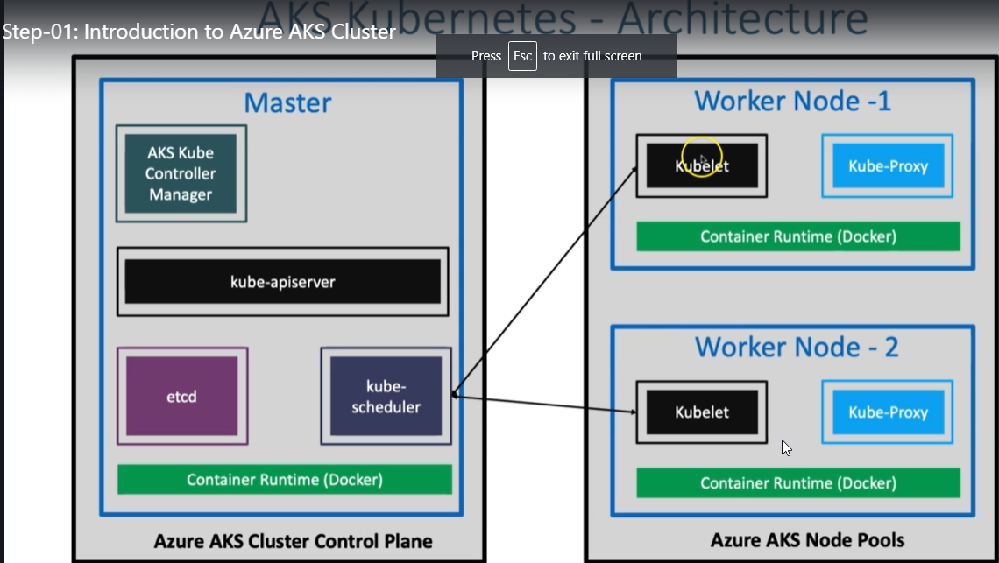

**Create a AKS Cluster**

1. Search for Kubernetes services and click on create
2. **Basics**
   1. **Subscription:** Free Trial
   2. **Resource Group:** Create New: aks-rg1
   3. **Kubernetes Cluster Name:** aksdemo1
   4. **Region:** (US) Central US
   5. **Kubernetes Version:** Select whatever is latest stable version
   6. **Node Size:** Standard DS2 v2 (Default one) (since the performance is high)
   7. **Node Count:** 1(one server)
3. **Node Pools**
   1. leave to defaults
4. **Authentication**
   1. Authentication method: System-assigned managed identity (if you enable this the container registry will be **enabled in the integration section)**
   2. Rest all leave to defaults
5. **Networking**
   1. **Network Configuration:** Advanced (for production)
   2. **Leave all subnet, Ips to default**
   3. **Network Policy:** Azure (which installs the Azure container network interface and cni plugins related to it so that our pod network all the networks will be with azure level network only)
   4. Rest all leave to defaults
6. **Integrations**
   1. Azure Container Registry: None (we can create it later when we integrate with azure container registration, registry build)
   2. leave to defaults
7. **Tags**
   1. leave to defaults
8. **Review + Create**
   1. Click on **Create**

Kubernetes control plane will be ready for us with one node as node pull nothing but one worker node will be created as part of that

Explore AKS Cluster using kubectl and Azure Mgmt Console

Cloud Shell - Configure kubectl to connect to AKS Cluster

Could shell related storage we can see in Resource group to access the shell go to shell.azure.com

To increase the text size, click on gear icon > change to medium and high

Generate the credentials to connect with Kubernetes cluster. We can do it using Azure CLI

Template

**az aks get-credentials --resource-group <Resource-Group-Name> --name <Cluster-Name>**

# Replace Resource Group & Cluster Name

**az aks get-credentials --resource-group aks-rg1 --name aksdemo1**

# List Kubernetes Worker Nodes

**kubectl get nodes :**  Kubectl Azure related under line cloud shell. It is available already there

**kubectl get nodes -o wide** it will provide the internal ip address, O.S image, docker details all it will provide

in the background it has created the kube config file here execute the below commands

cd /home/

ls

stack

cd stack/

in the kube config file we have the credentials downloaded for the Kubernetes cluster

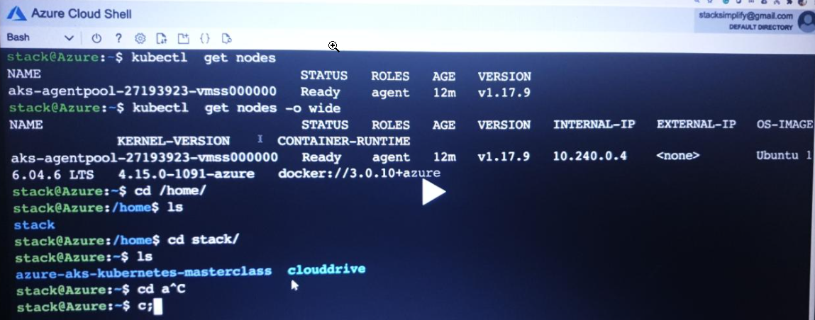

Explore Cluster Control Plane and Workload inside that

# List Namespaces

kubectl get namespaces

(or)

kubectl get ns

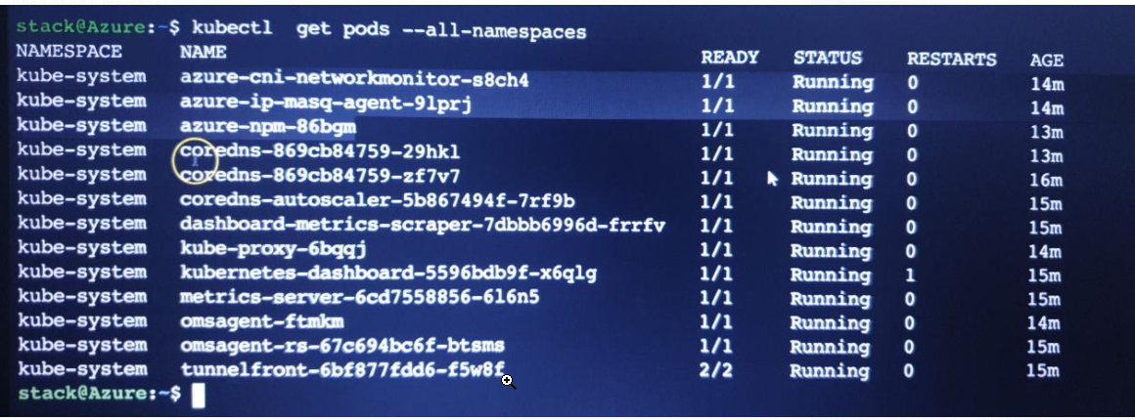

# List Pods from all namespaces

What are all the word loads running by default it will show

kubectl get pods --all-namespaces

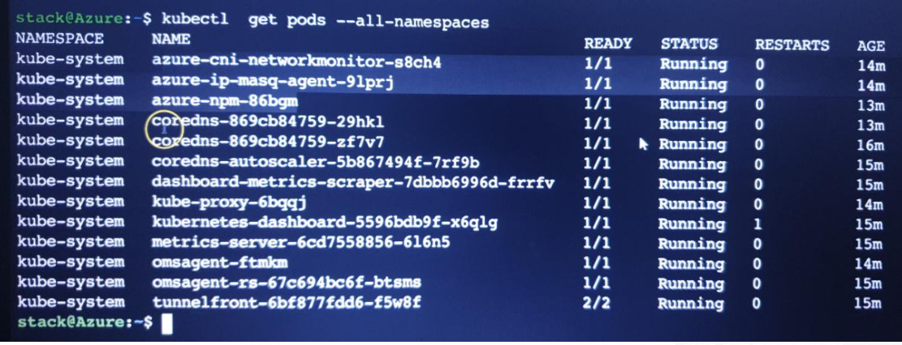

# List all k8s objects from Cluster Control plane: to know all the objects created in addition to pod. Pods are nothing but workloads. what are services, deployments, replicas whatever it has created

kubectl get all --all-namespaces



Explore the AKS cluster on Azure Management Console

* **Overview**
  + Activity Log: what is happening in Kubernetes cluster
  + Access Control (IAM)
  + Security
  + Diagnose and solver problems

**Name spaces** in console is same when we execute the kubectl get ns

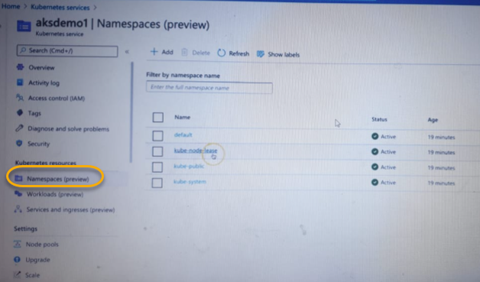

**Workloads**/ what are the pods available we can see

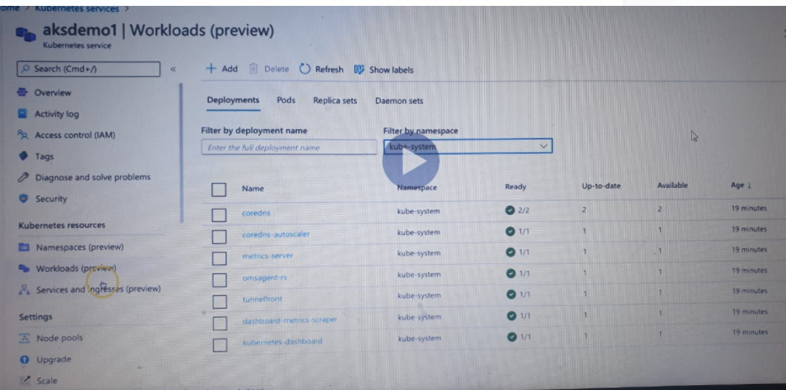

We can filter based on the name spaces

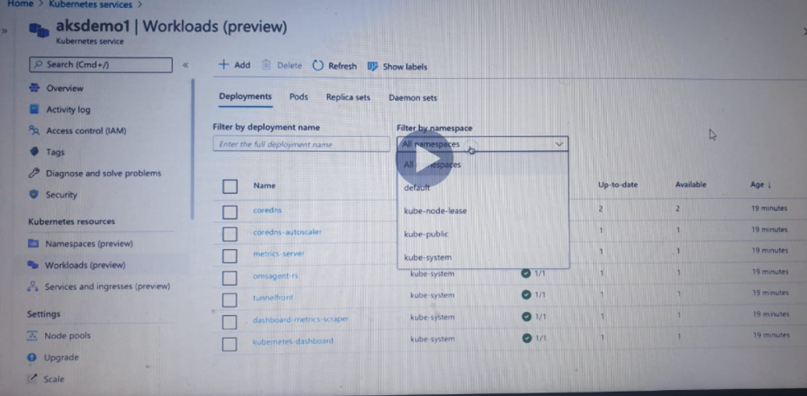

**Service and ingress:**  cluster IP we can see

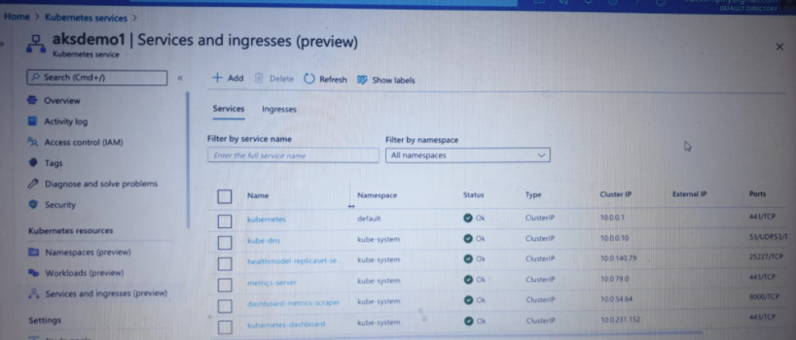

**Node pools** we are node we have created we can see here. We can scale up/upgrade the node pools

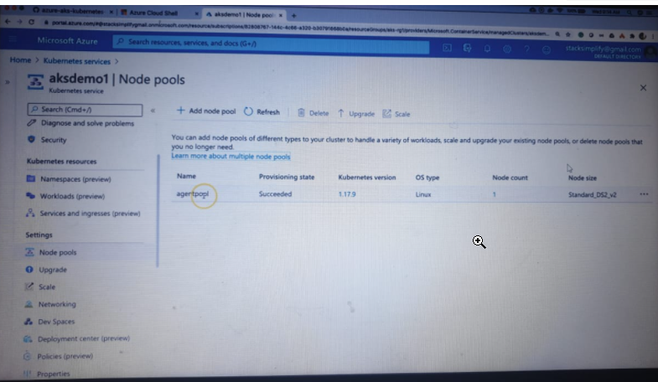

if you want and we can auto scale

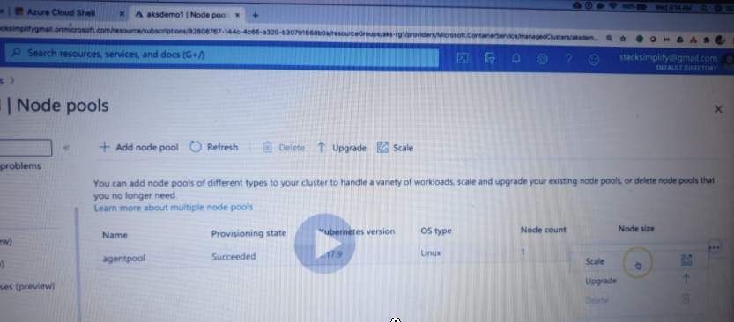

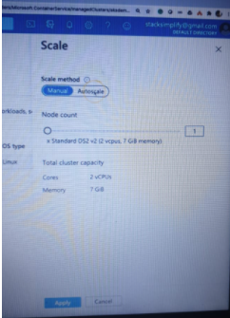

**Upgrade** If you want to upgrade the cluster to new version, we can upgrade it

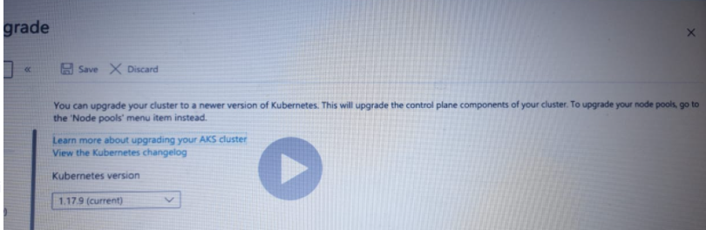

* **VM Scale Sets**
  + 1. Verify Azure VM Instances
    2. Verify if **Enhanced Networking is enabled or not** from AKS Cluster to external azure services it will go in a good manner

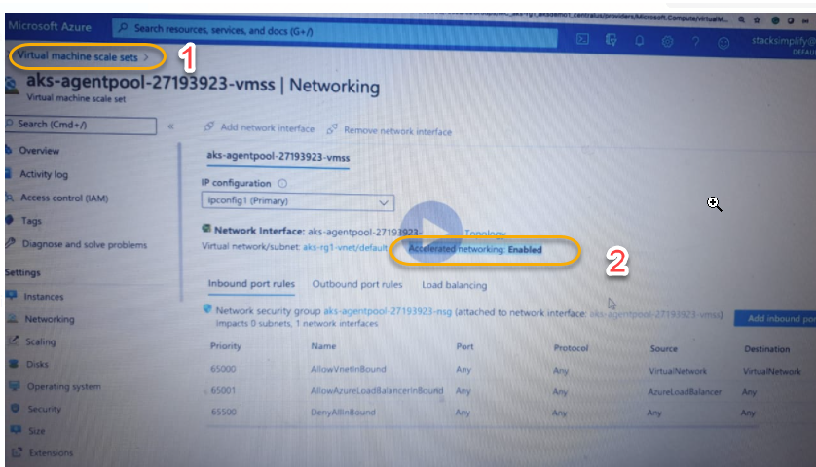

Local Desktop - Install Azure CLI and Azure AKS CLI

1. We can manage AKS cluster from our local machine. We have already azure cloud shell in place and why we need to do from our local
2. Commit to GitHub and downloading git pull to azure cloud shell and start using azure cloud shell becomes time taking process
3. So, the best way is installing azure CLI on local is the best option

Browse : <https://docs.microsoft.com/en-us/cli/azure/?view=azure-cli-latest> and install the below highlighted way

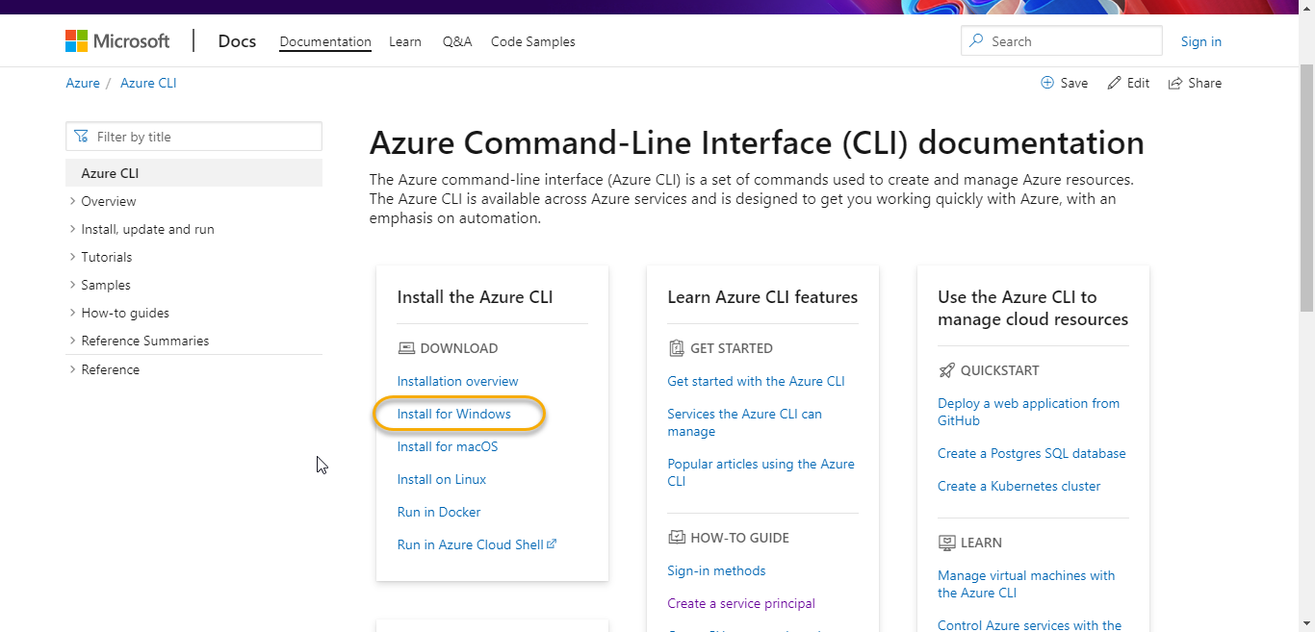

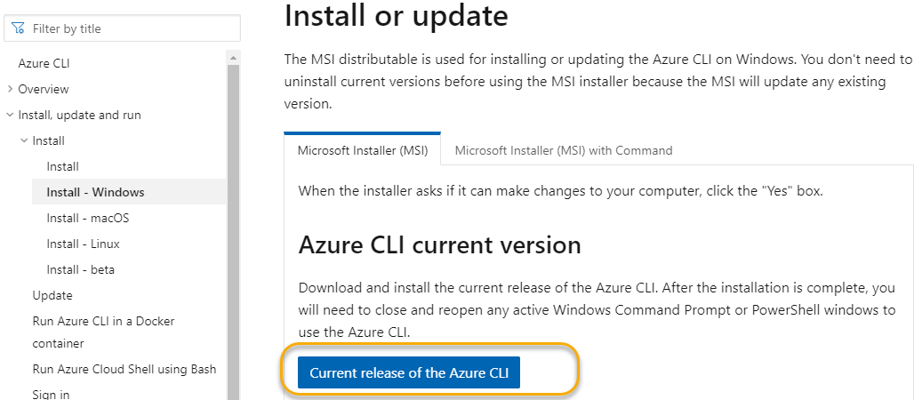

1. # Login to Azure
2. az login
3. Browse: <https://docs.microsoft.com/en-us/cli/azure/aks?view=azure-cli-latest>
4. And install the below highlighted one

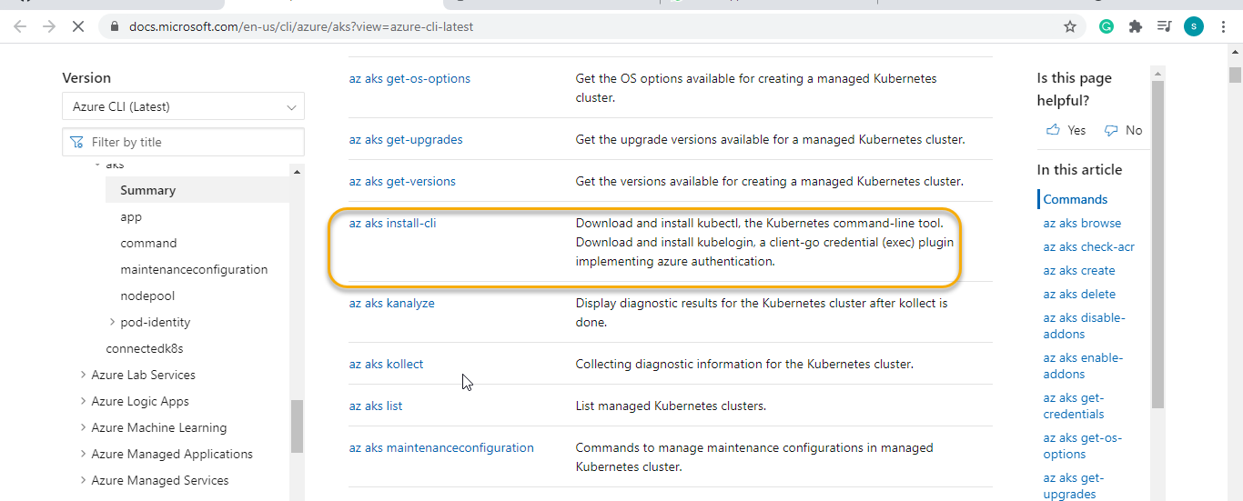

Or

1. # Install Azure AKS CLI

az aks install-cli

1. # Configure Cluster Creds (kube config)
2. az aks get-credentials --resource-group aks-rg1 --name aksdemo1
3. if it is already there then it will ask you update Y/N type Y and do the overwrite we can see the below

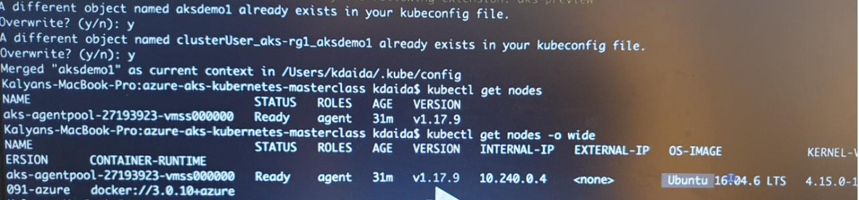

1. And we can run the basic commands to check if you are getting correct results

Deploy Sample Application and Test

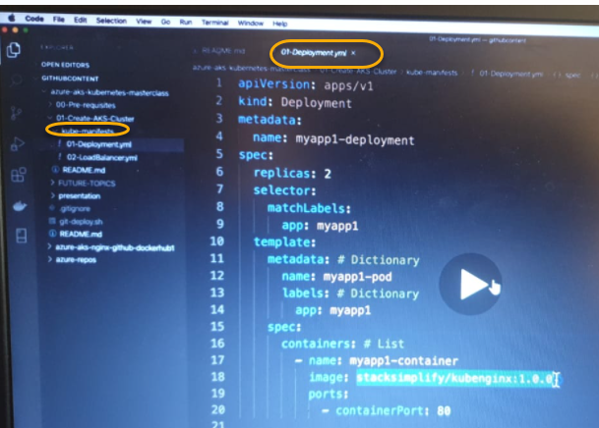

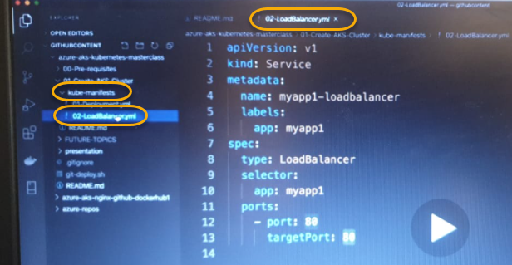

Change directory and apply the below commands

1. Kubectl apply -f kube-manifasts ( Deploy application)
2. And we see that deployment.yaml and service.yaml will be created
3. Run kubectl get pods (whatever the work loads/pods are running) we can see that
4. kubectl logs -f(pod name)

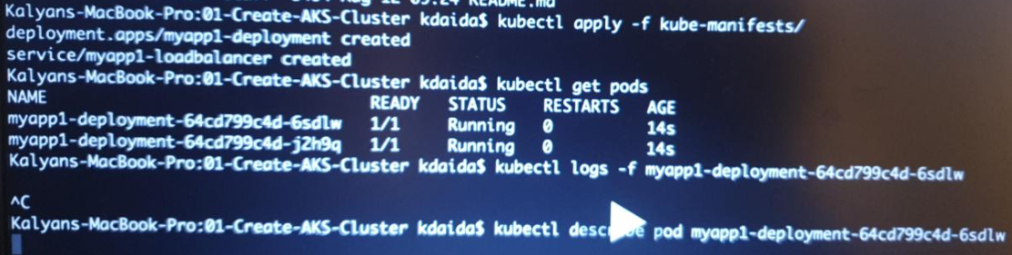

1. kubectl describe pod (pod name). It will show the image has pulled and created and started the container

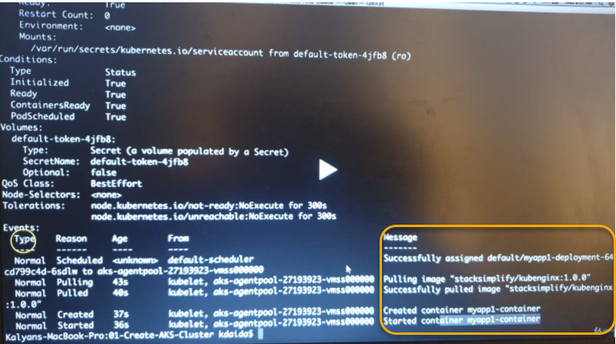

1. To know the deployment run kubectl get deployments
2. To know the services run kubectl get services/kubectl get svc

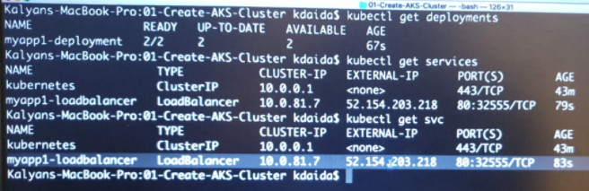

1. When we run the above query we will get the external IP and copy the IP and browse it in google

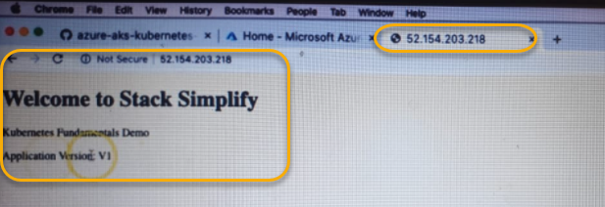

1. To delete the application ( kubectl delete -f kube-manifasts ) and if you run some basic commands like kubectl pods/deployemets it should show no services available

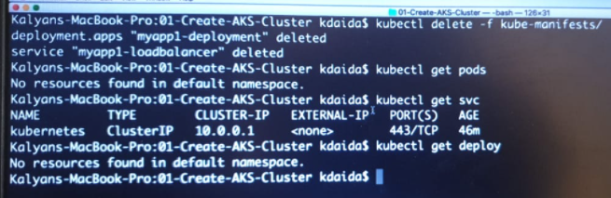

Introduction to Docker

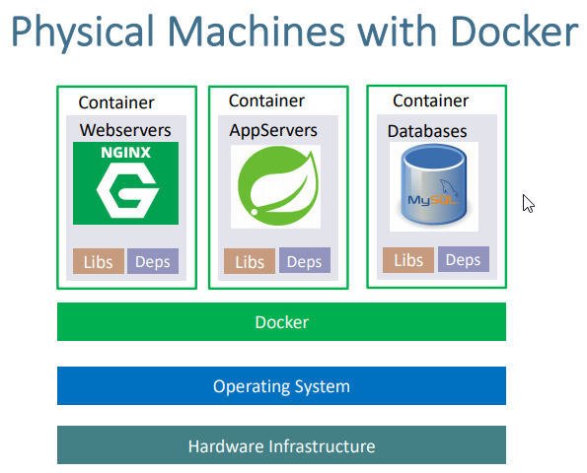

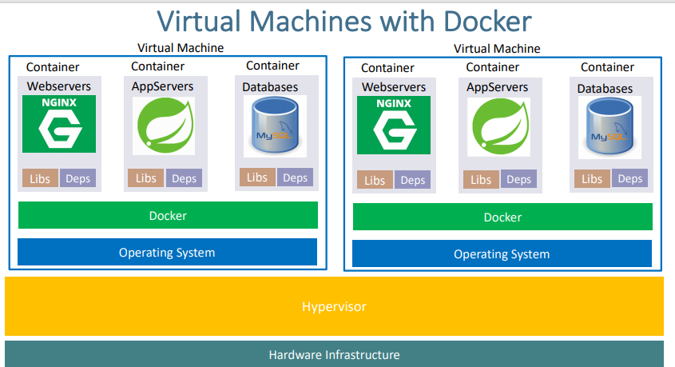

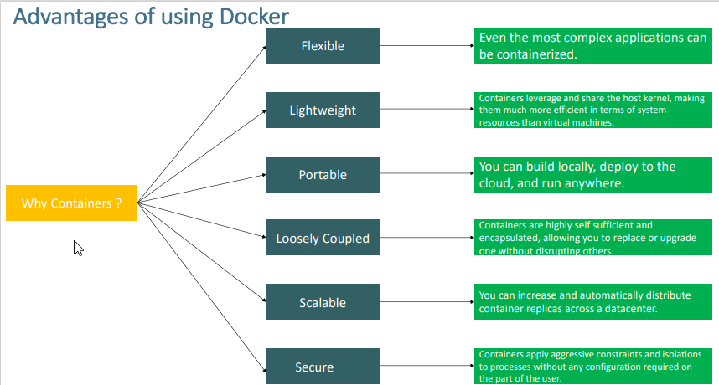

Kubectl get pods -o wide: will give the ip address internal which we can access inside the Kubernetes cluster. If you want to access the sample inginx application to our external world on your browser then we have a concept of Node port or load balancer services( we need to use this default)

**Step-06: Get YAML Output of Pod & Service**

**Get YAML Output**

# Get pod definition YAML output

kubectl get pod my-first-pod -o yaml

# Get service definition YAML output

kubectl get service my-first-service -o yaml

kubectl get all will give all resources in kubectl`

### Get Worker Nodes Status

* Verify if kubernetes worker nodes are ready.

# Configure Cluster Creds (kube config) for Azure AKS Clusters

az aks get-credentials --resource-group aks-rg1 --name aksdemo1

# Get Worker Node Status

kubectl get nodes

# Get Worker Node Status with wide option

kubectl get nodes -o wide

### Create a Pod

* Create a Pod

# Template

kubectl run <desired-pod-name> --image <Container-Image>

# Replace Pod Name, Container Image

kubectl run my-first-pod --image stacksimplify/kubenginx:1.0.0

### List Pods

* Get the list of pods

# List Pods

kubectl get pods

# Alias name for pods is po

kubectl get po

### List Pods with wide option

* List pods with wide option which also provide Node information on which Pod is running

kubectl get pods -o wide

### What happened in the backgroup when above command is run?

1. Kubernetes created a pod
2. Pulled the docker image from docker hub
3. Created the container in the pod
4. Started the container present in the pod

### Describe Pod

* Describe the POD, primarily required during troubleshooting.
* Events shown will be of a great help during troubleshooting.

# To get list of pod names

kubectl get pods

# Describe the Pod

kubectl describe pod <Pod-Name>

kubectl describe pod my-first-pod

### Access Application

* Currently we can access this application only inside worker nodes.
* To access it externally, we need to create a **NodePort or Load Balancer Service**.
* **Services** is one very very important concept in Kubernetes.

### Delete Pod

# To get list of pod names

kubectl get pods

# Delete Pod

kubectl delete pod <Pod-Name>

kubectl delete pod my-first-pod

## Step-03: Load Balancer Service Introduction

* What are Services in k8s?
* What is a Load Balancer Service?
* How it works?

## Step-04: Demo - Expose Pod with a Service

* Expose pod with a service (Load Balancer Service) to access the application externally (from internet)
* **Ports**
  + **port:** Port on which node port service listens in Kubernetes cluster internally
  + **targetPort:** We define container port here on which our application is running.
* Verify the following before LB Service creation
  + Azure Standard Load Balancer created for Azure AKS Cluster
    - Frontend IP Configuration
    - Load Balancing Rules
  + Azure Public IP

kubernets kube config for our local desktop. we are enabling the access for kubernetes cluster from our local desktop

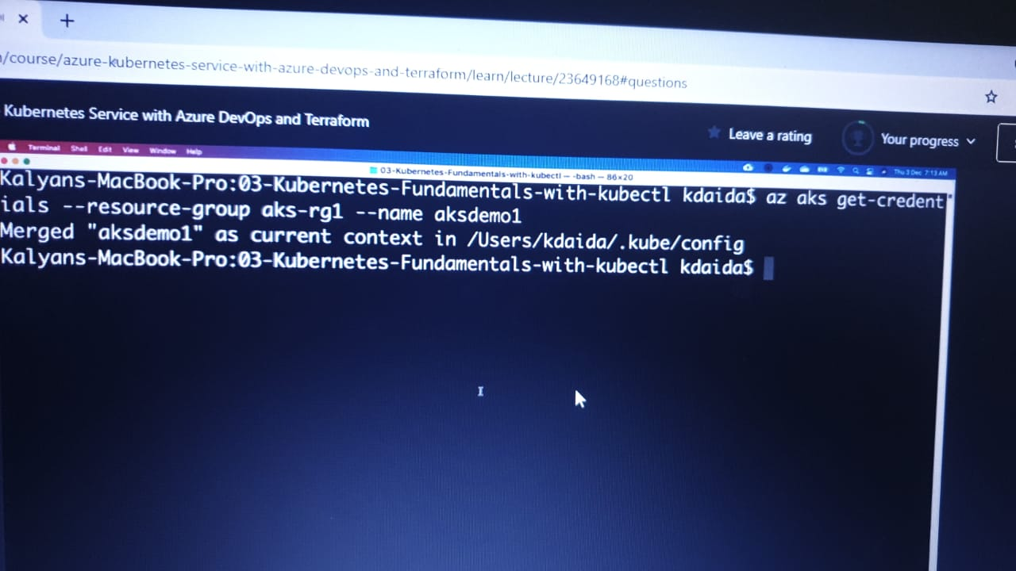

it will enable the credientals in .kube config

will provide the nodes in kubernetes cluster

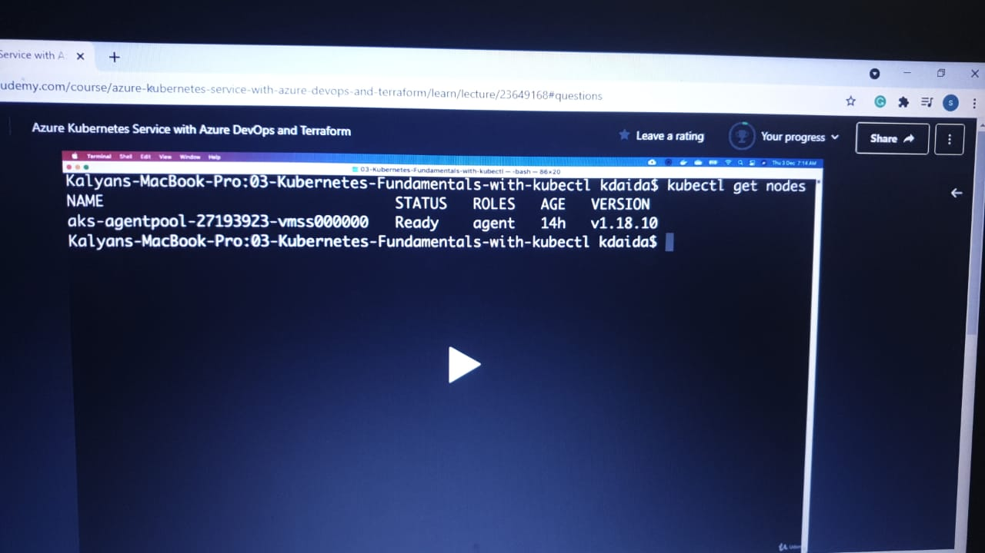

additional information about nodes

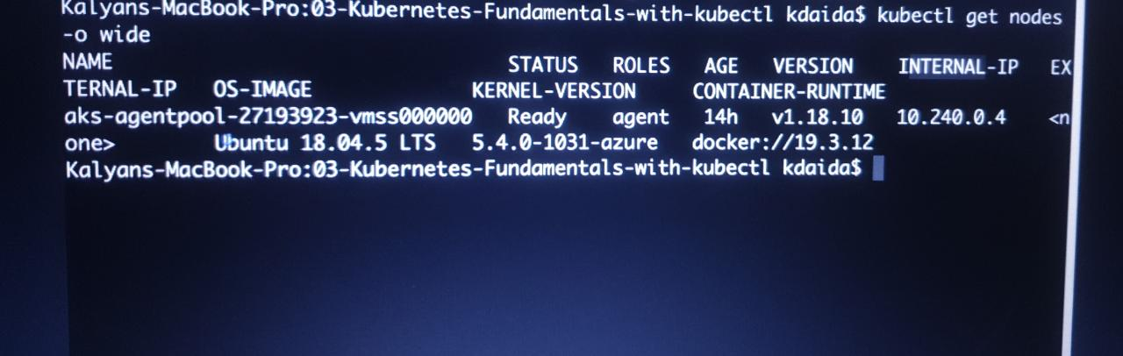

create the pod in an imperative way

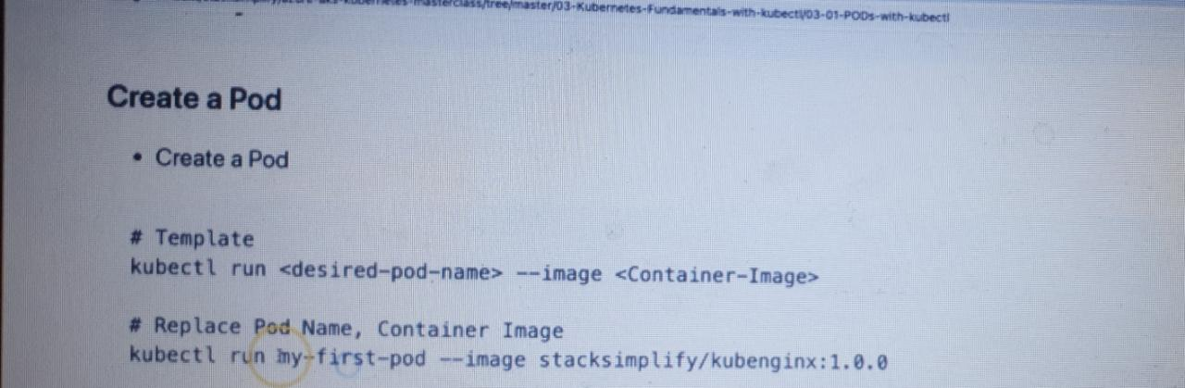

and it will download the kubenginx pod in kubernetes cluster

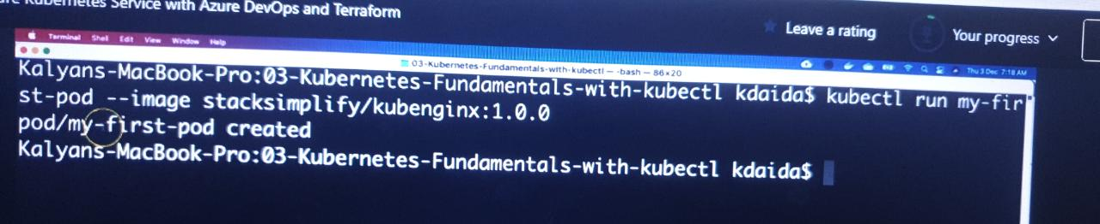

our first pod is created and will list in respective cluster

additional informationabout pod and Ip address we can see

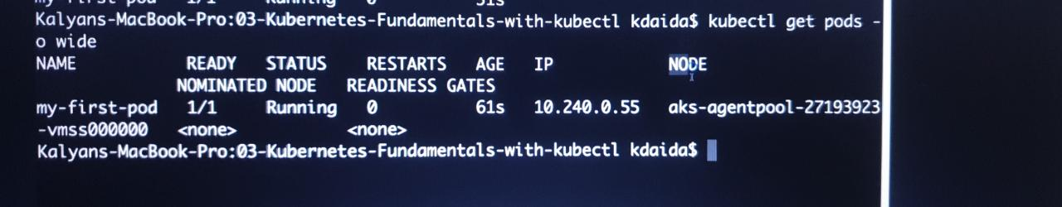

additional information for particular pod so use describe

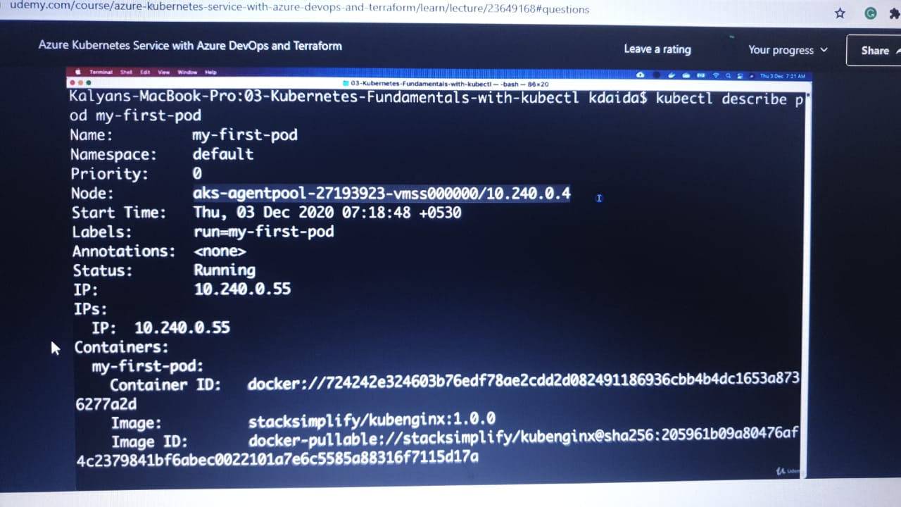

most important part in describing the pod is EVENT

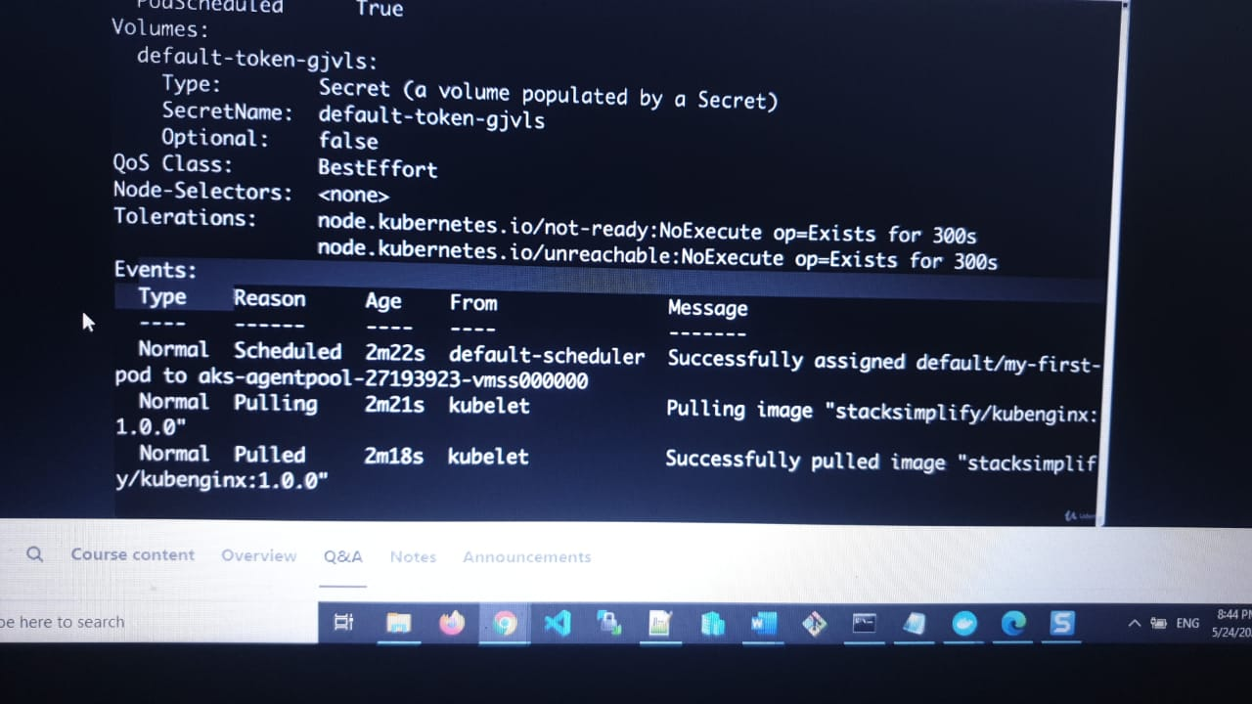

kube schedule will assign newly assigned pods to the respective nods

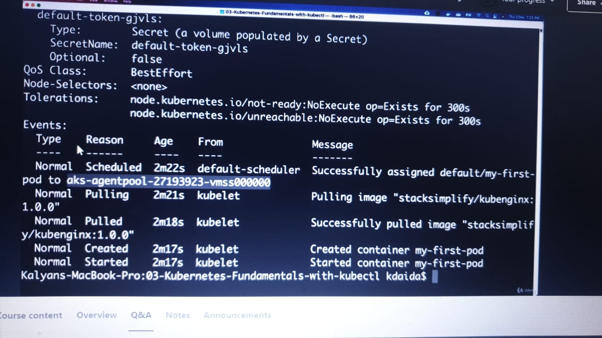

pulling, pushing created and started the pods

Kubectl get pods -o wide: will give the ip address internal which we can access inside the Kubernetes cluster. If you want to access the sample inginx application to our external world on your browser then we have a concept of Node port or load balancer services( we need to use this default)

when we go to the portal > load balancers ( is already created by default)> kubernetes.

we need to configure the Front end IP address for a new service

To delete the pod we need to use kubectl delete pod my-first-pod ( pod name)

Load balancer service connection

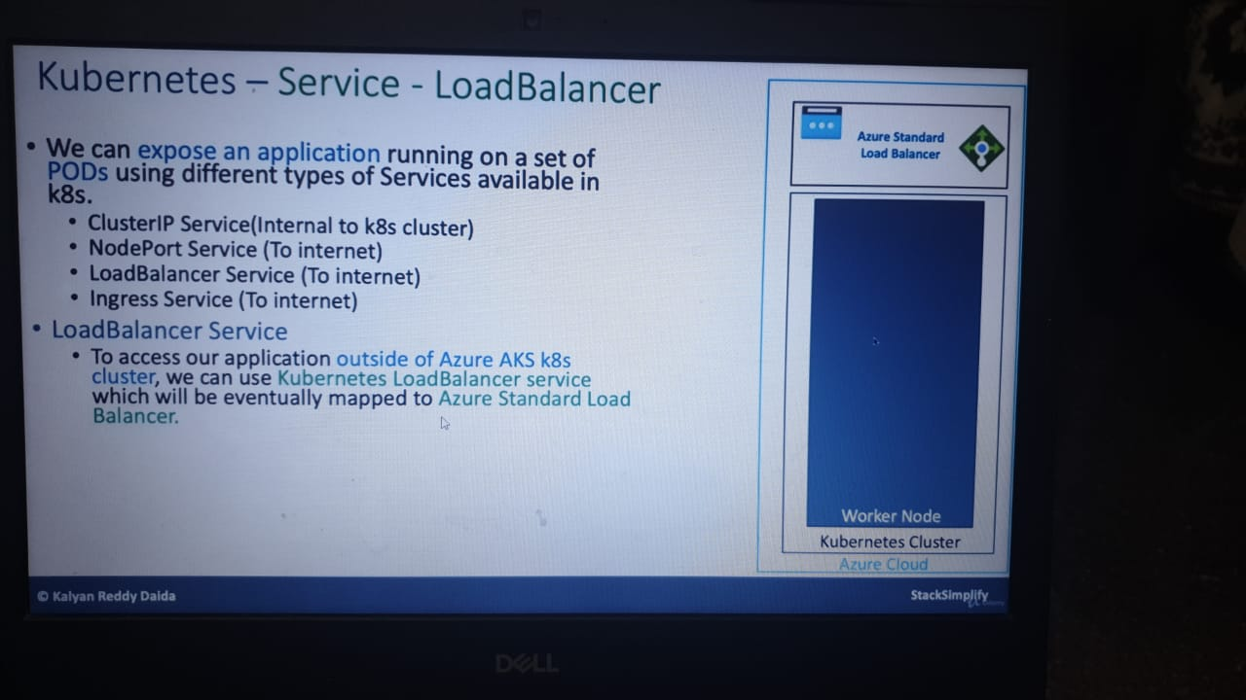

when ever we will create cluster automatically azure standard load balancer with a public Ip for kubernetes cluster is created.

whenever you configure kubectl az aks credentials in previous step. kubectl will call API which is nothing but kube API SERVER

Public Ip > load balancer > kubernetes cluster to perform the kubernetes adminstarive task

in the service we will have port 80 which cluster Ip address and target port is container port In a pod

by default cluster ip is created when we create node port service and load balncer service

and if you want to expose outside of the world then type is load balancer port

With respect to Kubernetes and it is a combination of Azure public IP address and Azure standard load balancer

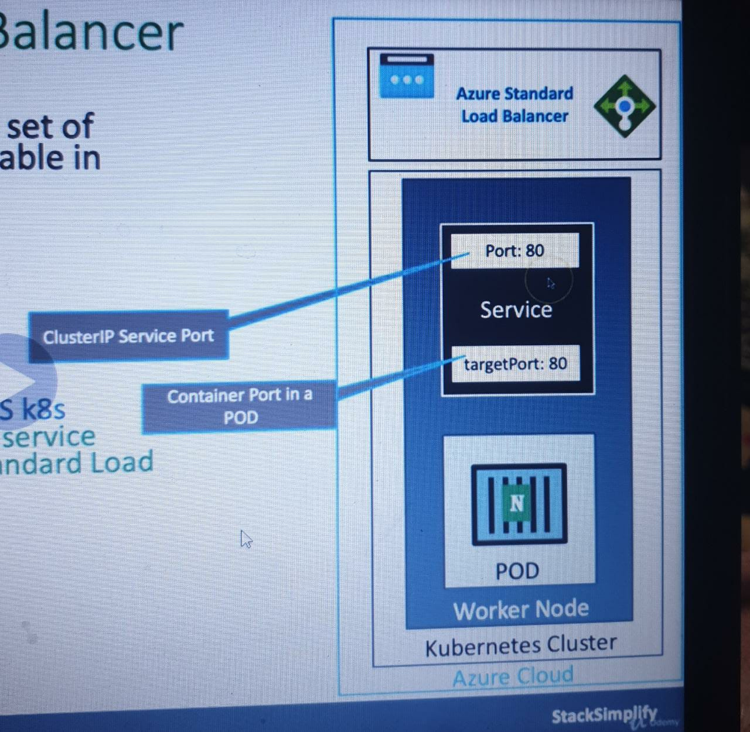

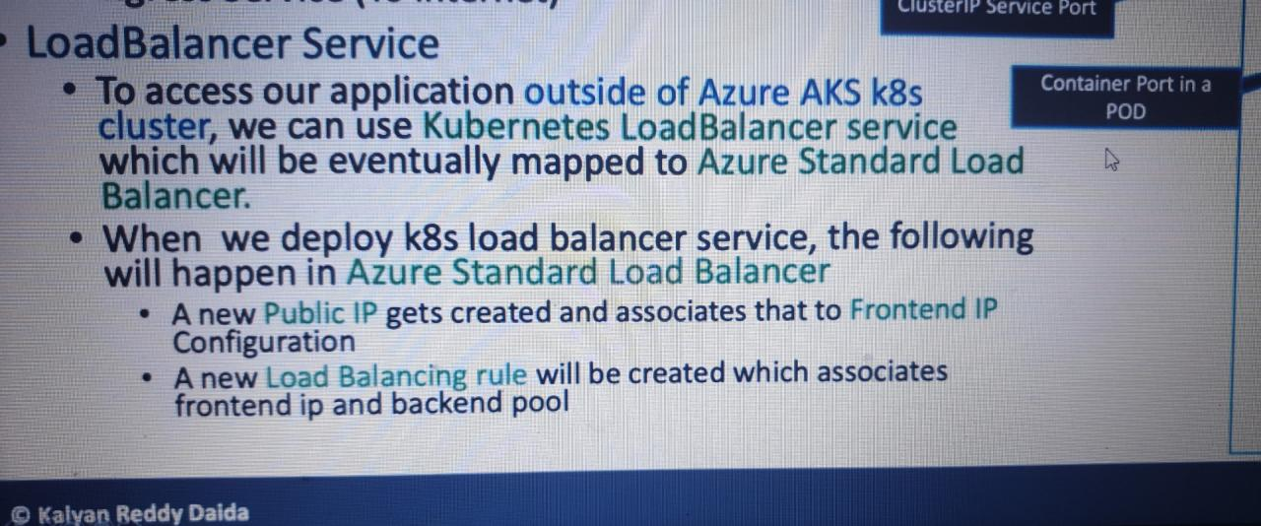

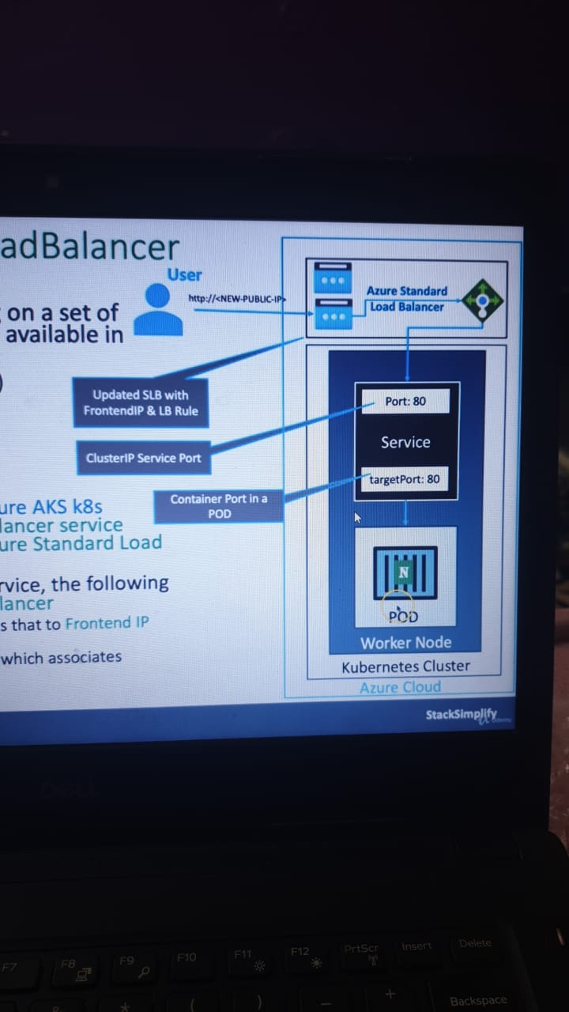

Demo - Expose Pod with a Service

Expose pod with a service (Load Balancer Service) to access the application externally (from internet)

Ports

port: Port on which node port service listens in Kubernetes cluster internally

targetPort: We define container port here on which our application is running.

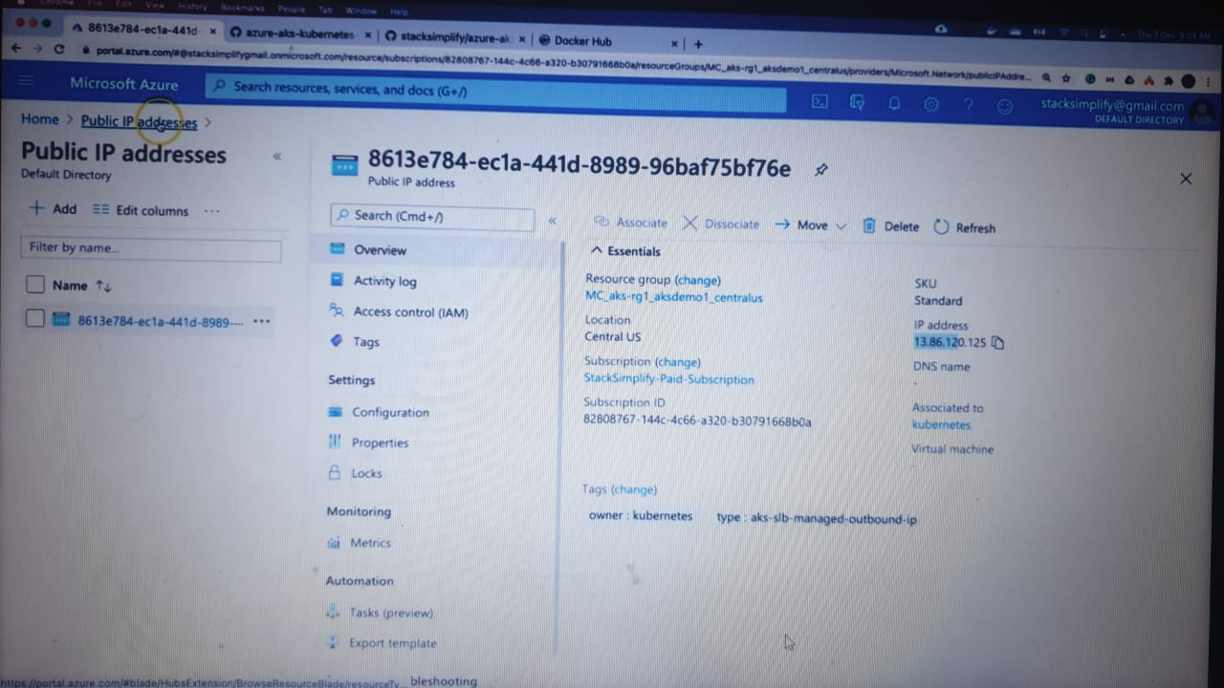

Public ip address



front end Ip for load balancer

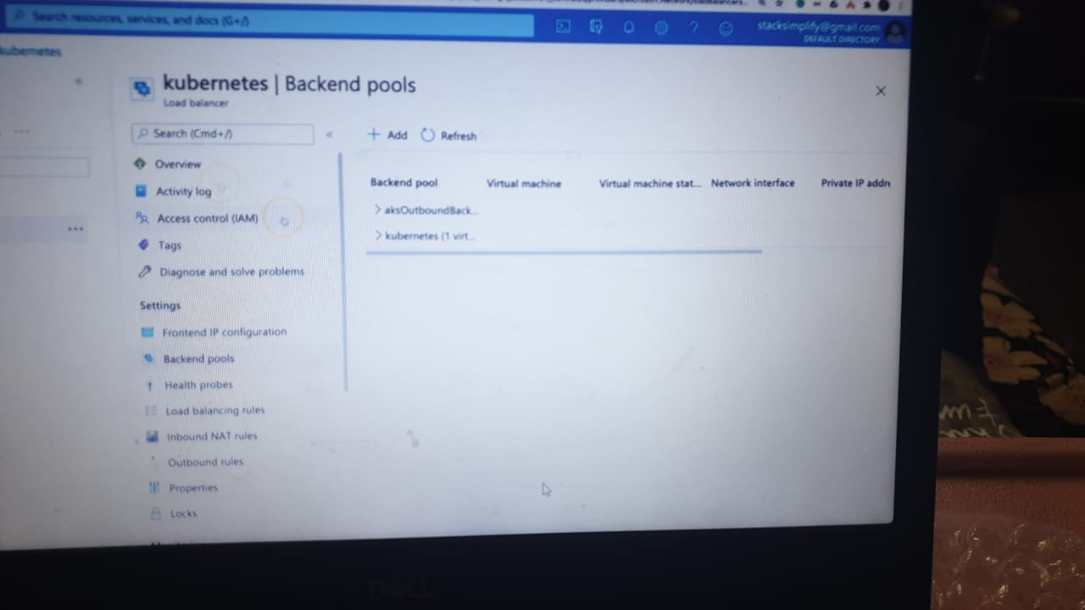

backend pool configuration which is kubernetes node

# Create a Pod

kubectl run <desired-pod-name> --image <Container-Image>

kubectl run my-first-pod --image stacksimplify/kubenginx:1.0.0

# Expose Pod as a Service

kubectl expose pod <Pod-Name> --type=LoadBalancer --port=80 --name=<Service-Name>

kubectl expose pod my-first-pod --type=LoadBalancer --port=80 --name=my-first-service

# Get Service Info

kubectl get service

kubectl get svc

create a pod with a service

now if you type kubectl get pod gives a pod information

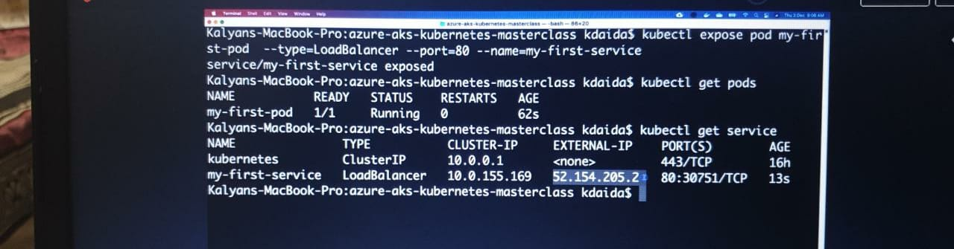

if you access the kubectl external ip

# Get Service Info

kubectl get service

kubectl get svc